Tiffany Donnelly

UX Design

Professor Talebi

Contents

Identify 3 competitors. 2

What is the name of each competitor or their company/organization name? 2

What is the URL to each competitor’s website? 2

Explain whether each website is from a direct or indirect competitor? Write a 2-4 sentences explaining your logic for each website (total of 6-12 sentences). 2

Include a screenshot of each home page. 3

Include a screenshot of each website’s menu and make sure to label each graphic with the name of the competitor (just the text of the name will do under the graphic). 4

Explain how each of the 3 menus work. Write 3-5 sentences each (total of 9-15 sentences). 6

Content and navigation - Rank best menu to worst and explain your logic. 7

Aesthetics and style 7

Take screenshots of examples of color and imagery from each website. 7

Discuss how color and imagery is used on each site. Write 2-3 sentences each (total of 6-9 sentences). Discuss if you think the color and imagery is used well, whether it reinforces their brand… etc. 9

Heuristic analysis 9

Select 3 of the heuristics from the above link (make sure to list the names). Compare and contrast your 3 competitors using those 3 heuristics. Write 2-4 sentences each (total of 8-12 sentences). 9

UI animations 9

Explain how each site uses UI animation. Write 2-3 sentences each (total of 6-9 sentences. 9

Are the UI animations for each site valuable, fluff (just for looks) or somewhere in the middle? 9

How do the competitors fare against each other with UI animation? 9

Score each website. 9

Score each website for the 4 categories shown in the below table (UX for the Web page 48). Replace the example competitors and scores with your own. 9

# Identify 3 competitors.

## What is the name of each competitor or their company/organization name?

OurTinyFamily LLC

Lioden Ltd

Snail Games

## What is the URL to each competitor’s website?

Indomita.net

Wolvden.com

Dappervolk.com

## Explain whether each website is from a direct or indirect competitor? Write a 2-4 sentences explaining your logic for each website (total of 6-12 sentences).

I would say that all three falls into the category of indirect competitor. All of them are different niches, and slightly different in delivery and what they focus on, but they do take up part of the same market, and they have remarkably similar or even the same customers.

Indomita is different because it focuses on the roleplay aspect and playing individual characters, its different because of the customization options it gives. It also focuses on one single type of animal, being horses.

Wolvden is similar in this way in that it focuses on wolves and heavy on customization of singular characters. Wolvden and Indomita also both allow you to create factions (herds, packs) with these characters in their niche animal groups.

Dapper volk is different than the other two but still takes up the same player base. This game focuses on the players avatar and the world exploration.

I would say these differ from my idea because its more about building up the homestead and a variety of animals without the same customization tools, there are many different aspects that people can focus on instead of being completely niche to one breed of animal or focusing on a singular avatar. But the issue lies where some of these games are more popular than others because of how well they accomplish the goals of the same player base.

Some ways they are similar is with Indomita and Wolvden having dynamic layering art images which would eventually be implemented in my idea, and realistic or in-depth genetic coding when breeding animals.

## Include a screenshot of each home page.

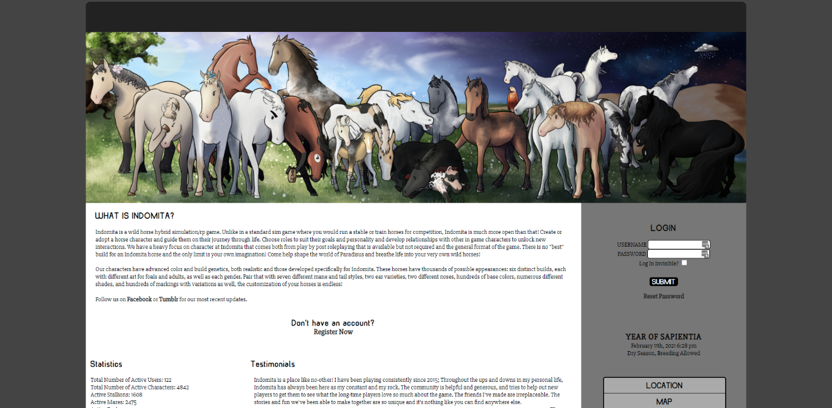

Indomita.net

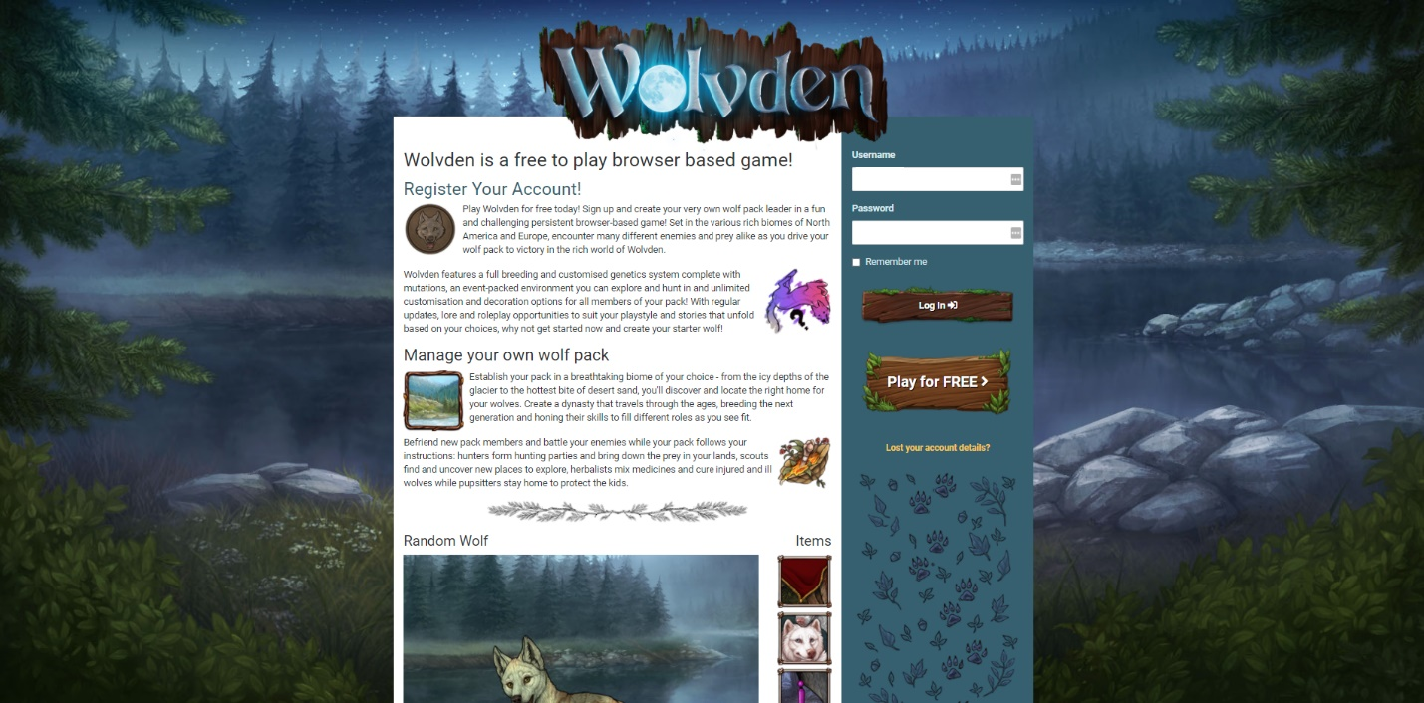

Wolvden.com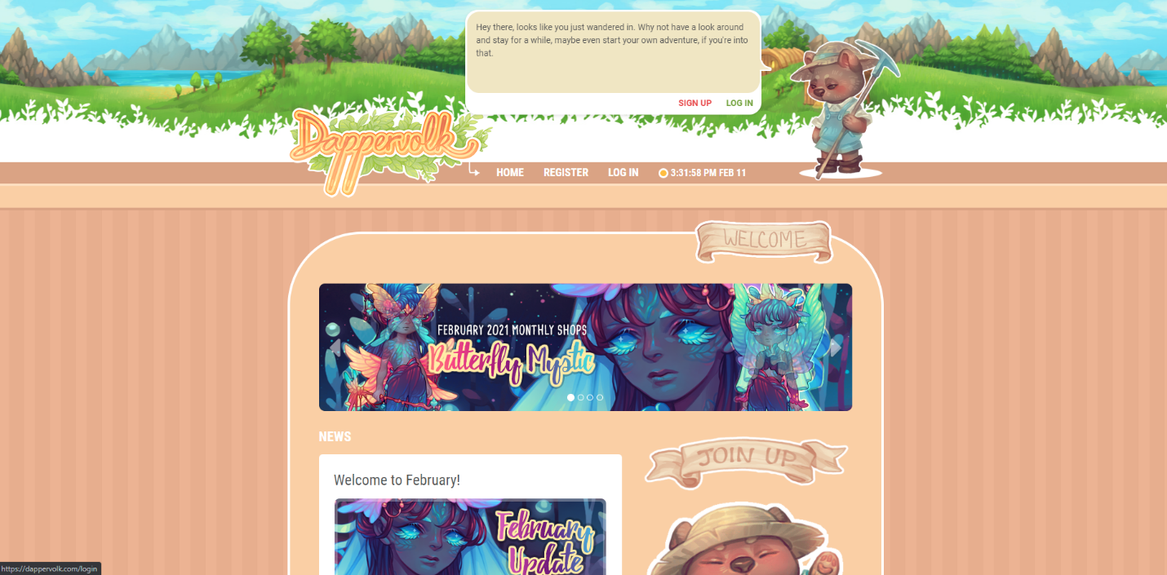

## Include a screenshot of each website’s menu and make sure to label each graphic with the name of the competitor (just the text of the name will do under the graphic).

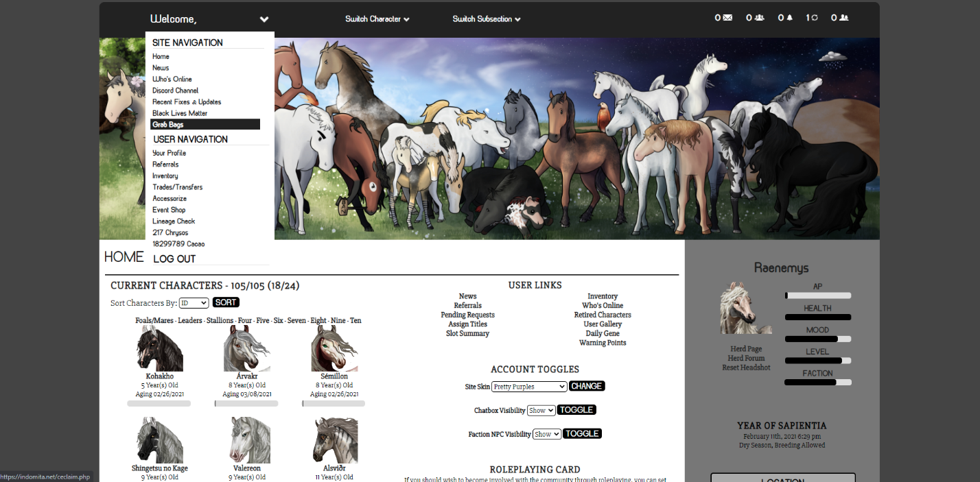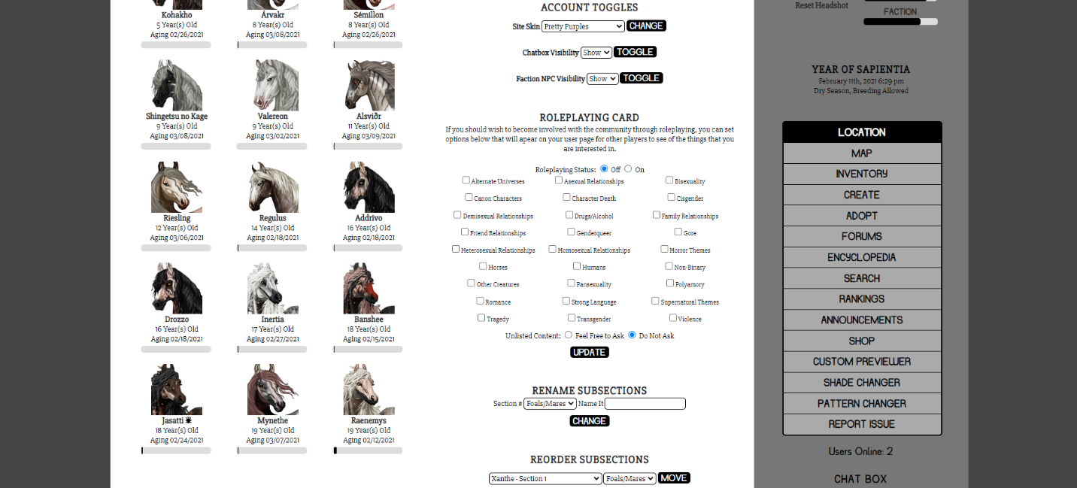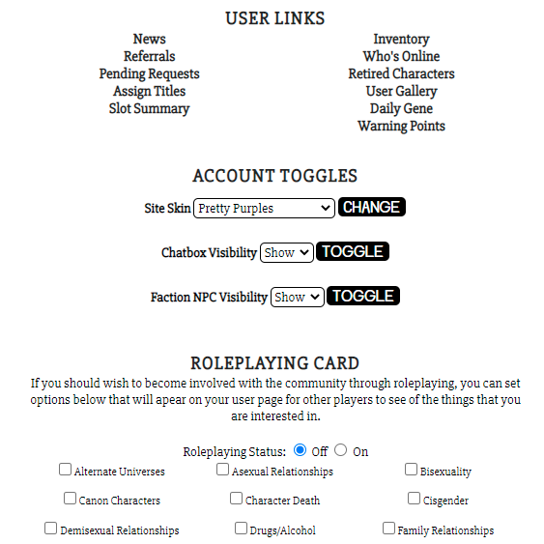

Indomita.net

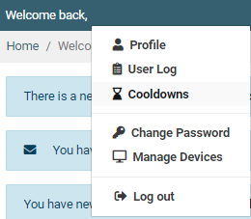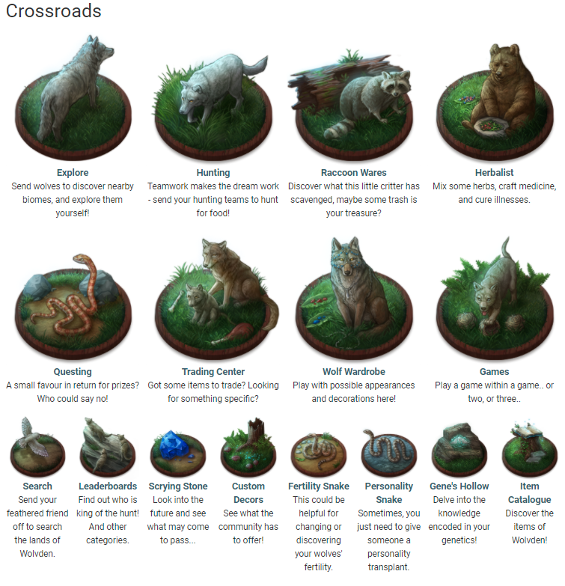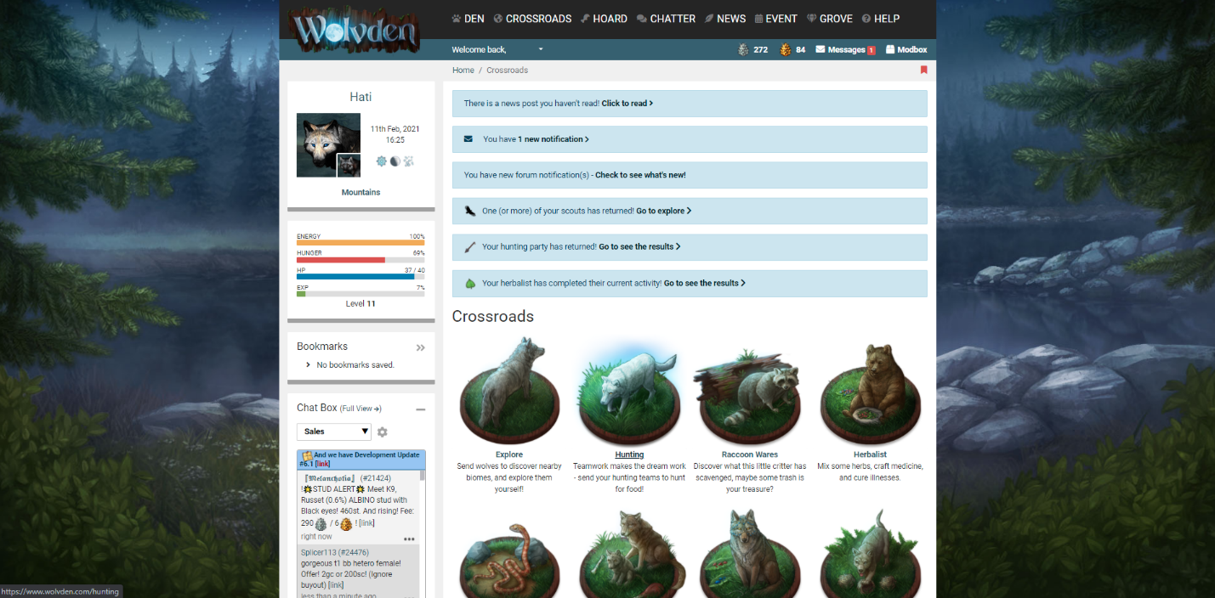

Wolvden.com

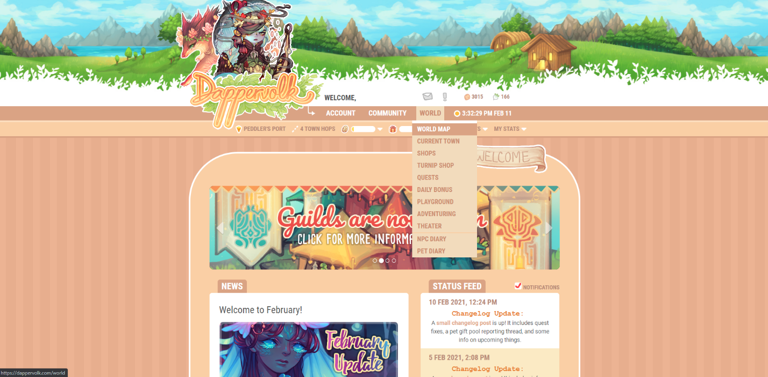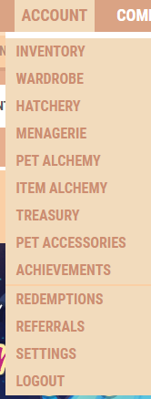

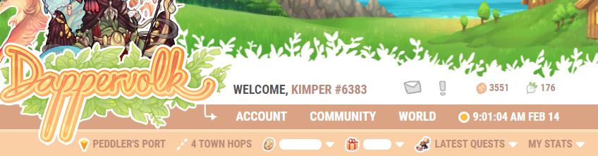

Dappervolk.com

## Explain how each of the 3 menus work. Write 3-5 sentences each (total of 9-15 sentences).

Indomita’s menus are kind of all over the place. There is a drop-down menu at the top with user buttons, like logging out, user inventory, in-game currency count, etc. Then it has a menu on the right side of the page with site navigation, also on the home page there is a lot of customization items like editing your profile, moving subsections. There is a lot of info and its hard to find because it could be anywhere behind all these buttons and options.

Wolvden has a simpler menu with site navigation at the top, then some of them lead to a visual sub-menu like the crossroads. Under the username there is a user menu to manage devices logged in, change password, log of items used and useful information like that. Its much easier to navigate compared to Indomita.

Dappervolk is like Wolvden with an even more simplified menu site navigation is under one menu (which also leads to sub-menus in some cases), community interaction under another and user account information under the first.

None of the menu’s cause major issues with use, such as the page jumping, they all open seamlessly.

## Content and navigation - Rank best menu to worst and explain your logic.

Best: Dappervolk

Wolvden

Worst: Indomita

Indomita is hard for new users to navigate because everything is all over the place. Its old and outdated and is not a good user experience when trying to navigate the different pages and subpages or even find what you are looking for because of the structure.

Dappervolk is the best (probably tied with Wolvden) because its simplified and everything that is related is put together so that you know where to look for what you are trying to find. Wolvden is also good because its not as consolidated, but I would put it slightly below because it could still be difficult because of strangely named options for navigation, it can be hard to know where something you are looking for is located.

# Aesthetics and style

## Take screenshots of examples of color and imagery from each website.



Indomita.net



Wolvden.com

Dappervolk.com

## Discuss how color and imagery is used on each site. Write 2-3 sentences each (total of 6-9 sentences). Discuss if you think the color and imagery is used well, whether it reinforces their brand… etc.

Indomita is pretty simple, it has different options for skins to appeal to different types of people and their color preferences. I think the imagery does reinforce the brand because it shows the characters who are main characters in the lore of the game in most of the skins. But one main issue is that the art styles all vary because they are made by different people over a 5 year period. The colors not so much, because there are so many different skins it is difficult to relate one to the website over the other especially across different players.

Wolvden has a consistent color theme. The art is all the same exact art that appears throughout the game and nothing feels inconsistent. It makes you feel comfortable and like it all flows together. I think the colors are nice and its instantly recognizable as Wolvden.

I think Dappervolk is similar in that all of the art is consistent. Even when art is made by different people, they had strict guidelines to follow to keep the “painterly style” that Dappervolk advertises itself with. The colors are bright and fun and are easily recognizable as the brand coloring and fit with the theme and style.

# Heuristic analysis

## Select 3 of the heuristics from the above link (make sure to list the names). Compare and contrast your 3 competitors using those 3 heuristics. Write 2-4 sentences each (total of 8-12 sentences).

Consistency and standards

I would say that Indomita suffers from not having consistency or good standards of use. There are lots of hidden submenu’s all over the website, there is not easy way to find where something is located without asking someone who is more knowledgeable. People might not even recognize the website if they see a screen shot of it using a different site-skin than they are used to. The other websites are much more consistent and have clearer standards especially when it comes to navigation and design.

Aesthetic and minimalist design

I would say that as far as design goes Indomita might meet that standard but it does not do it well. I think that Wolvden and Dappervolk are slightly better designed even if it doesn’t exactly fit into the name of minimalism. But Indomita does not have a good aesthetic, the other two websites have clearly defined aesthetics (consistency in color, art, etc) that make them instantly recognizable to users.

Help and documentation.

Indomita’s help is usually user based because the encyclopedia system is hard to use, A lot of issues you get an error to report it to the admin but no additional information. Its sometimes possible for people to lose their accounts because of the archaic system for email and password changing. Wolvden and Dappervolk are much more modern, though sometimes things are user based, they are able to have a lot more account options to help users reset their passwords and recover their accounts.

# UI animations

## Explain how each site uses UI animation. Write 2-3 sentences each (total of 6-9 sentences.

Indomita: the farthest Indomita goes for animation is a drop-down menu here or there, or highlighting text that is hovered over. The website feels old and clunky. It would probably be unfitting for it to have much animation unless it under-went a full makeover.

Wovlden: Has a lot of UI animation with highlighting images when they are hovered, coloring text that is hovered over. It feels more updated.

Dappervolk: Dappervolk also does not have as much UI animation, there are some drop downs and highlighting but otherwise not much is going on. Even without it, the website feels good and new.

## Are the UI animations for each site valuable, fluff (just for looks) or somewhere in the middle?

I think the highlights are valuable on each site, because its easy to know what button you are about to click.

I think maybe some of the UI animation on Wolvden might be fluff but I do think it adds some value in that its pretty to look at and something new I haven’t seen before.

## How do the competitors fare against each other with UI animation?

Wolvden would probably be the most interesting as far as UI animation, the others are less but with different results. Indomita having none reinforces the idea that its old and clunky. But for Dappervolk it still feels new and vibrant without the fancy UI animations.

# Score each website.

## Score each website for the 4 categories shown in the below table (UX for the Web page 48). Replace the example competitors and scores with your own.

|  |  |  |  |
| --- | --- | --- | --- |
|  | Indomita | Dappervolk | Wolvden |
| Content & Navigation | 2 | 8 | 7 |
| Aesthetics & Style | 2 | 9 | 9 |
| Heuristic Analysis | 3 | 9 | 9 |
| UI Animation | 2 | 5 | 8 |
|  | 2.25 | 7.75 | 8.25 |